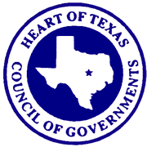
Judge Jay Elliott Judge Richard Duncan
President Secretary/Treasurer
Mayor Geary Smith Russell Devorsky
Vice-President Executive Director

Emergency Preparedness Advisory Committee Meeting
9:30 AM, Wednesday, November 8, 2023
HOTCOG – 1514 S. New Road, Waco, Texas

- Welcome and Introductions
  - Guest recognition –
  - Member introductions –

- Determination of Quorum

- Proof of Posting

- Public Comment

- Sub-Committee Reports

- Chair’s Report

- HOTCOG Staff Reports
  - Communications Project Updates

- New Business - Consideration of and/or Action On
  - Review, Discuss, and Approval of September 13, 2023 - EPAC Meeting Minutes
  - Current and future projects Waco FD CBRNE and McLennan County Bomb Squad
  - Discussion of IPAWS for Public Alerts
  - ENS User Training/ new features
  - Discuss Bylaws and future revisions.

- Announcements or Future Business Items

- Next EPAC Meeting
Wednesday, January 10, 2024, at 9:30 AM at the HOTCOG

- Adjournment

